*2021*

*Dealer Handbook*



**Premium Modular Floating Docks and Ports**

Welcome to Wave Armor – The most advanced generation of modular floating dock systems. Our premium floating docks and ports are designed to be practical, timeless and comfortable. We believe that modern waterfront living isn’t just a trend but a lifestyle.

### From INNOVATION to INSPIRATION

As a Wave Armor Dealer, you are part of the #1 Fastest-Growing floating dock company on the planet. We are REVOLUTIONIZING the industry through INNOVATION and our COMMITMENT to being the BEST! Our team is laser-focused on supporting you with the most innovative products and tools to grow and expand your customer base. Wave Armor has set the benchmark for Quality, Thoughtful Design, Aesthetics, and Consumer Demand. Every other dock manufacturer looks to Rick Johanneck, The Wave Armor Team, and You as our Distributor for inspiration.

We Provide:

* **Best in class innovation** – Continuous development of new truly unique products and accessories
* **Unmatched quality** – Made in the USA. Roto-molded & Foam Filled. Wave Armor docks and ports are the most durable and unsinkable floating docking systems in the industry
* **Most aesthetically pleasing dock** - Molded flagstone texture, multi-colored Pebble Beach finish, and patented hidden H-Beam connectivity make it the most beautiful dock on the market
* **Ultimate customization** – Wave Armor Docking systems are modular accommodating any dock design and provide the widest variety of accessories to turn docks into true outdoor living spaces
* **Best in class warranty:** 
  + 10-year residential warranty on docks, 8-year residential warranty on ports
  + 3-year commercial warranty on docks and ports
* Preparing you for success:
  + Best in class sales, marketing, and customer service team for you and your customers
  + The Wave Armor team is always available and can provide you the tools, training, and resources necessary to be successful
* **Telling our story** – We are continuously building Wave Armor brand awareness and providing our dealers with tools to connect with new customers. Dealers have access to:
  + Content – New articles consistently produced on Wave Armor products, info, tips, features, and benefits. Dealers to use socially, email newsletters, website, and in-store
  + New lifestyle & product images added annually to showcase Wave Armor products, and to keep your marketing assets fresh and up-to-date
  + Library of videos to use as needed, with multiple new videos becoming available for 2021
  + Sales support materials – catalogs, brochures, sell sheets
  + Apparel and promotional items available for purchase

### REQUIREMENTS OF WAVE ARMOR DEALERS

* **Experience, expertise, and knowledge** – In-depth knowledge and relationships within the Marine and Marine leisure sector, particularly within your market
* **A solid position within your market** - That is visible and provable to us through your current customer reach and traditional and digital marketing efforts
* Proudly offer the Wave Armor product line to your customers
  + Represent and promote Wave Armor products on a dedicated area of your website, for which we will provide you with the product images and specifications to achieve this
  + Display Wave Armor product in your showroom or lot
  + Prominently display POP materials and brochures in your showroom
  + Market and advertise Wave Armor products following our Minimum Advertised Price (MAP) structure
  + List “Wave Armor authorized dealer” on your business cards
  + Follow Wave Armor branding guidelines for all logo and brand use, including all marketing materials (Any digital or printed materials that are not created by Wave Armor must have approval from Wave Armor’s marketing department prior to distribution)
* Provide the highest level of customer service and support to your customers
  + Staff training and education on Wave Armor products
  + Marketing campaigns such as social media, digital/print, sales brochures, and email blasts
  + Regular cold-call visits to commercial projects in your market
  + Site assessments to ensure that installations are performed easily and smoothly for the customer
  + Exhibit or participate at (1) local Boat shows with Wave Armor products, branding, and marketing materials *dependent upon Covid-19 related closures
* The ability to purchase and stock. Dock, port, and raft units purchased in “Truckload, Half Truckload, or LTL” quantities of $10,000 or greater. *Exceptions may apply for Universal Products, attachment kits, and misc. items
* **Collaborative partnership planning**
  + Annual Business Review
    - A collaborative review of your sales of the previous year looking at total dollars, market reach, and business to business activity
  + Annual purchase plan
    - A Wave Armor team member will review and collaborate with you on an annual strategy and sales plan

### WAVE ARMOR DEALER PROGRAMS

We offer three levels of dealer programs; the plan is tiered to provide increasing discounts as your business and volume grow with us.

There are three tiers:

* Premier Dealer
* **Elite Dealer**
* **Master Dealer**

Each level has its own incentives and requirements.

The Premier Dealer is our entry point for direct dealers. Dealers at this level are not required to hold inventory of Wave Armor products. We target a minimum annual purchase plan of $50,000 to be accepted into the program but exceptions will be considered at this level. A dealer’s location, long-term plan, and circumstances will all be considered and may affect qualification level decisions. Dealers that do not meet this minimum purchase level will be reviewed by the sales management team to determine future dealer status.

A dealer’s qualification level will be determined based on the previous product year’s purchase volume. Once the next qualifying purchase level is achieved, any additional purchases will be made at the higher discount till the following year.

The implementation of our annual business review and business planning process has and will continue to play an important role in collaborating with Wave Armor to understand your business and help you grow to the next level.

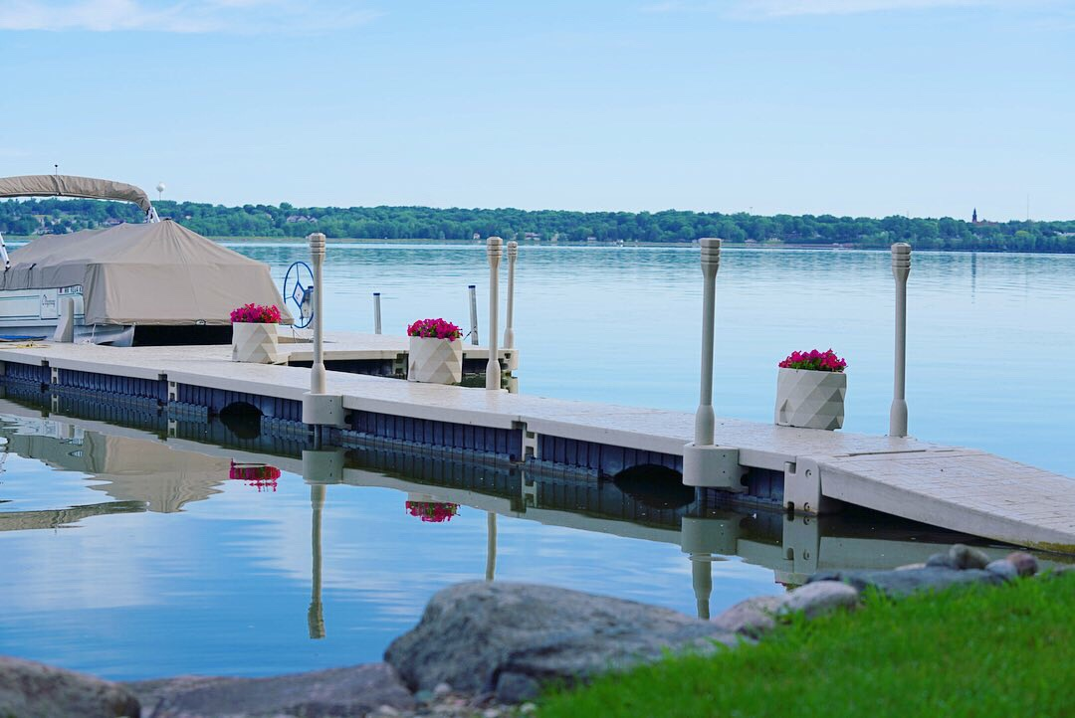

### PREMIER DEALER

Premier Dealers will qualify to purchase Wave Armor products at a discount of 25% off listed “MAP”. Also, they will receive additional rebates and incentives as listed below. The requirements and incentives are as follows:

Requirements:

* Represent and promote Wave Armor products on a dedicated area of your website, for which we will provide you with the product images and specifications to achieve this.
* Advertise Wave Armor products following our Minimum Advertised Price (MAP) structure.
* Display POP Material and brochures prominently in the Dealer’s showroom or office. (Dependent upon space)
* Display Wave Armor product in your showroom or lot.
* Follow Wave Armor branding guidelines for all logo and brand use, including all marketing materials. Any digital or printed materials that are not created by Wave Armor must have approval from Wave Armor’s marketing department before distribution.
* Must attend (1) Corporate/Distributor sponsored show, expo or event representing Wave Armor, if requested.
* Maintain/Update company contact information annually for Wave Armor marketing resources.
* Provide Warranty Registration Information to customers within 30 days of product installation/delivery.
* Provide Warranty Support directly to the customer after the sale/installation utilizing the Wave Armor “Warranty Program”.
* Present Wave Armor products to the consumer utilizing the highest level of customer service and professionalism.
* Properly train and educate your staff on the full Wave Armor line of products.
* Maintain a relationship in good standing with the Wave Armor Territory Manager.
* Participate in annual business review and planning with your Wave Armor Territory Manager.
* Stock of Wave Armor floating docks, PWC ports, boat ports or rafts is not required but is suggested. Please discuss your seasonal stocking needs with your Wave Armor Territory Manager.
* Annual minimum product purchase volume of ***$50,000*** (Plus Annual Growth Expectation).

Incentives:

* Purchase at a discount of 25% off listed “MAP”.
* Early Buy: Earn an extra 5% off orders placed October 15th – November 30th. Minimum Early Buy Order of

***$15,000***. * Additionally, all invoices paid in full by December 31st will receive a 2% credit issued to the account. Early Buy orders must ship within one week of staging, with the last truck shipping before February 28th. Invoices must be paid by April 15th. All open orders still here after February 28th and/or unpaid invoices on April 15th will forfeit the discount.

* Additional Marketing Support provided:
  + $150 Merchandise credit towards Wave Armor Branded Apparel and Items for your sales/service team.
  + 2021 Co-op Marketing Program & Dealer Advertising Guidelines.
* Additional Sales Support provided:
  + Lead Distribution from Wave Armor upon completion of the Dealer Locator / Referral Request Form.
  + Opportunity to schedule the “NEW” Wave Armor Show Trailer at your local event (if available).

### ELITE DEALER – STOCKING DEALER

Elite Dealers will qualify to purchase Wave Armor products at a discount of 32% off listed “MAP”. Also, they will receive additional rebates and incentives as listed below. The requirements and incentives are as follows:

Requirements:

* Represent and promote Wave Armor products on a dedicated area of your website, for which we will provide you with the product images and specifications to achieve this.
* Advertise Wave Armor products following our Minimum Advertised Price (MAP) structure.
* Display POP Material and brochures prominently in the Dealer’s showroom or office. (Dependent upon space).
* Display Wave Armor product in your showroom or lot.
* Follow Wave Armor branding guidelines for all logo and brand use, including all marketing materials (Any digital or printed materials that are not created by Wave Armor must have approval from Wave Armor’s marketing department before distribution).
* Must attend (1) Corporate-sponsored show or event representing Wave Armor. *Contingent upon covid-19.
* Maintain/Update company contact information annually for Wave Armor marketing resources.
* Provide Warranty Registration Information to customers within 30 days of product installation/delivery.
* Provide Warranty Support directly to the customer after the sale/installation utilizing the Wave Armor “Warranty Program”.
* Present Wave Armor products to the consumer utilizing the highest level of customer service and professionalism.
* Properly train and educate your staff on the full Wave Armor line of products.
* Maintain a relationship in good standing with your Wave Armor Territory Manager.
* Participate in an annual business review and planning with your Wave Armor Territory Manager.
* Stock a minimum of $40,000 worth of Wave Armor floating docks, PWC ports, boat ports, or rafts. The combination of which will be dependent on the local market and agreed upon by you and your Wave Armor Territory Manager.
* Annual minimum product purchase volume of ***$150,000*** (Plus Annual Growth Expectation).

Incentives:

* Purchase at a discount of 32% off listed “MAP”.
* Early Buy: Earn an extra 5% off orders placed October 15th – November 30th. Minimum Early Buy Order of

***$50,000***. * Additionally, all invoices paid in full by December 31st will receive a 2% credit issued to the account. Early Buy orders must ship within one week of staging, with the last truck shipping before February 28th. Invoices must be paid by April 15th. All open orders still here after February 28th and/or unpaid invoices on April 15th will forfeit the discount.

* Additional Marketing Support provided:
  + $150 Merchandise credit towards Wave Armor Branded Apparel and Items for your sales/service team.
  + 2021 Co-op Marketing Program & Dealer Advertising Guidelines.
* Additional Sales Support provided:
  + Lead Distribution from Wave Armor upon completion of the Dealer Locator / Referral Request Form.
  + Opportunity to schedule the “NEW” Wave Armor Show Trailer at your local event (if available).
  + Wave Armor Sales Representative Attendance at a Tradeshow or Marketing Event (w/ Prior Scheduling).

### MASTER DEALER – STOCKING DEALER

Master Dealers will qualify to purchase Wave Armor products at a discount of 37% off listed “MAP”. Also, they will receive additional rebates and incentives as listed below. The requirements and incentives are as follows:

Requirements:

* Represent and promote Wave Armor products on a dedicated area of your website, for which we will provide you with the product images and specifications to achieve this.
* Advertise Wave Armor products following our Minimum Advertised Price (MAP) structure.
* Display POP Material and brochures prominently in the Dealer’s showroom or office. (Dependent upon space).
* Display Wave Armor product in your showroom or lot.
* Follow Wave Armor branding guidelines for all logo and brand use, including all marketing materials (Any digital or printed materials that are not created by Wave Armor must have approval from Wave Armor’s marketing department before distribution).
* Must attend (1) Corporate-sponsored show or event representing Wave Armor. *Contingent upon covid-19.
* Maintain/Update company contact information annually for Wave Armor marketing resources.
* Provide Warranty Registration Information to customers within 30 days of product installation/delivery.
* Provide Warranty Support directly to the customer after the sale/installation utilizing the Wave Armor “Warranty Program”.
* Present Wave Armor products to the consumer utilizing the highest level of customer service.
* Properly train and educate your staff on the full Wave Armor line of products.
* Maintain a relationship in good standing with the Territory Manager.
* Participate in an annual business review and planning with Wave Armor and the Territory Manager.
* Stock a minimum of $100,000 worth of Wave Armor floating docks, PWC ports, boat ports, or rafts. The combination of which will be no less than upon by the Territory Manager.
* Annual minimum product purchase volume of ***$300,000*** (Plus Annual Growth Expectation).

Incentives:

* Purchase at a discount of 37% off listed “MAP”.
* Early Buy: Earn an extra 5% off orders placed October 15th – November 30th. Minimum Early Buy Order of

***$100,000***. * Additionally, all invoices paid in full by December 31st will receive a 2% credit issued to the account. Early Buy orders must ship within one week of staging, with the last truck shipping before February 28th. Invoices must be paid by April 15th. All open orders still here after February 28th and/or unpaid invoices on April 15th will forfeit the discount.

* Additional Marketing Support provided:
  + $150 Merchandise credit towards Wave Armor Branded Apparel and Items for your sales/service team.
  + 2021 Co-op Marketing Program & Dealer Advertising Guidelines.
* Additional Sales Support provided:
  + Lead Distribution from Wave Armor upon completion of the Dealer Locator / Referral Request Form.
  + Opportunity to schedule the “NEW” Wave Armor Show Trailer at your local event (if available).
  + Wave Armor Sales Representative attendance at a tradeshow or marketing event (w/prior scheduling).
  + Wave Armor sponsored sales contest for your sales team OR (3) Wave Armor Coolers for promotions.

### DIRECT DEALER ACKNOWLEDGEMENT

This Direct Dealer Acknowledgement is made effective as of by and between Wave Armor, LLC, a Minnesota company, located at 411 W. Congress Street, Maple Lake, Minnesota 55358 (“Company”) and

, located at

(“Dealer”).

Please initial to confirm each statement:

|  |  |
| --- | --- |
|  | I understand all invoices are sent via e-mail to the A/P contact listed above. |
|  | I understand that my payment terms are NET 30. Payment must be received within 30 days of invoice date. Accounts with unpaid balanced past 30 days without authorization may be placed on credit hold and be  subject to review. |
|  | I understand that all orders need to be e-mailed to [orders@wavearmor.com.](mailto:orders@wavearmor.com.%20) |
|  | I understand if I am approved for credit terms that I may choose between using my credit terms OR paying by credit card. If I pay by credit card I must do so within 1 business day of my order shipping and I will incur a 4% credit card processing fee. |
|  | I understand Wave Armor will not accept same-day orders. |
|  | I understand there will be a $250 Order Change Fee charged for any order that is changed within 48 hours of scheduled shipping or pick-up. |
|  | I understand that I am responsible for all transportation costs from Wave Armor’s Maple Lake MN location. |
|  | I agree to keep Wave Armor’s Dealer price list and Dealer programs confidential. |
|  | I understand that upon delivery, I have 15 days to inspect the products and file a claim for any damaged products that I have received. Photos and a clear description of the damage are required when submitting a  claim. |
|  | I confirm receipt of the Dealer Program Requirements & Incentives that relate to my pricing tier. |
|  | I acknowledge that I have been placed in the Dealer Program checked below:  Premier  Elite  Master |

Dealer Signature: _

________________________________________________________

Dealer Printed Name:

Title: Date:

WA Territory Rep Signature:

WA Territory Rep Printed Name:

### 2021 “MAP” PRICING AND INTERNET PROGRAM

**DESCRIPTION**

**2021 Dealer Minimum Advertised Price (MAP) and Internet Sales Program.**

This is available to you as an authorized Wave Armor Dealer or Distributor that plans to utilize a “published price” format in any marketing or advertising campaign. If all of your advertised prices comply with this MAP Program, you will be authorized to sell and ship Wave Armor products direct to customers within the continental United States.

Written authorization will be required for any dealer or distributor to ship product internationally or be considered an international business partner.

**PURPOSE**

To encourage customer interaction with a focus on the features unrelated to price, such as performance, quality, lifestyle engagement, safety features, warranty coverage, durability, etc., during the retail sales process.

**MAP PROGRAM TERMS**

**Wave Armor Brand Products:** The advertised price for all Wave Armor products cannot be presented to the public any lower than the published MAP pricing. The MAP price may or may not be less than the published MSRP pricing on the company’s websites at [WWW.WAVEARMOR.COM](http://WWW.WAVEARMOR.COM/) or [WWW.WAVEARMOR.NET.](http://WWW.WAVEARMOR.NET/)

**Product Branding:** Wave Armor has invested and will continue to invest in its proprietary branding in the public marketplace. All public advertising shall include the “Wave Armor” Logo and proprietary color scheme. The product name and description used in any and all forms of advertising media will directly reflect those listed in the “Wave Armor Catalog” and on the company’s websites at [WWW.WAVEARMOR.COM](http://WWW.WAVEARMOR.COM/) or [WWW.WAVEARMOR.NET](http://WWW.WAVEARMOR.NET/).

No private labeling or branding will be authorized without written consent from the Wave Armor corporate offices. To inquire about private labeling and the volumes required please contact your distributor or Territory Sales Manager.

**MAP PROGRAM BENEFIT**

Dealers that participate (see next page), and comply with the terms of this MAP Program, will be authorized to MARKET, SELL AND SHIP all Wave Armor products by catalog, flyer or via the internet.

**ELIGIBLE PRODUCTS**

**Wave Armor Docks:** Dock Sections, Dock Anchoring Kits, Dock Connection Kits, Dock Bumpers and Dock Accessories

**Wave Armor Boat Ports:** Boat Ports including the Genesis Series Boat Ports, Extreme Series Boat Ports, Connection Kits, Anchoring Kits, Accessories and Replacement Parts

**Wave Armor PWC Ports:** PWC Ports including the Evolution Series Ports, SLX Series Ports, Evolution Connections and Accessories, SLX Connections and Accessories

**Wave Armor Swim Rafts and Kayaks:** Otter Island Swim Rafts, Raft Anchoring Kits, Raft Accessories, Raft Replacement Parts. Kayaks, Kayak Assist Units, Kayak Racks, and Kayak Accessories

**Wave Armor Coolers:** Coolers in the sizes listed at [WWW.WAVEARMOR.COM](http://WWW.WAVEARMOR.COM/)

**Wave Armor Accessories and Branded Apparel:** Universal Boat and Dock Products including but not limited to Benches, Bumpers, Dock Boxes, Fenders, Racks, Wheels, and all Wave Armor branded apparel.

**INTERNET POLICY**

All sales activities, including those over the internet, should be consistent with the obligations and limitations in the current Wave Armor pricing structure. Any statements made through the internet shall include but not be limited to “Additional Freight and Sales Tax where Applicable”. Any advertised prices greater than MSRP will be considered acceptable if they are represented as “all inclusive” or “value added” proposition (e.g., “Installation included” or “fully assembled”).

**FINAL SALE PRICE**

This MAP Program applies only to advertised prices and the prices used for the marketing of Wave Armor Products. The final per unit sale price to the consumer of any Wave Armor products will be determined by you as the “Authorized Dealer”, following negotiation, discounts if any, fees or surcharges if any.

Internet sales may be transacted at prices below MAP Program pricing, so long as the sale price is not reflected on the web page, or in the secure internet shopping cart (e.g., acceptable pricing descriptions or statements are “call for pricing”, or “request a price at [email@XYZ.com](mailto:email@XYZ.com)” for actual “Specials” and any available “Discount Programs”). It is *not acceptabl*e to reflect lower prices on the web page or electronic shopping cart. It is not the intent or suggestion that the terms of the Wave Armor MAP Program or any descriptive pricing model dictates or controls the sale price to the consumer.

**MAP RELIEF PERIOD / “SPECIAL SALE” POLICY**

Beginning on August 1st and ending on October 30th of every model year it will be allowable for dealers to offer an additional 10% discount below current listed MAP pricing. All advertising must include an end date for the discount no later than October 30th of that year and will require a description of the sale such as “End of Season Clearance”, “Blowout”, “Inventory Reduction Sale” or a statement explaining the reason for any additional discounts.

**VIOLATIONS**

A violation is defined as any marketing or advertising that represents Wave Armor Products at prices below the aforementioned MAP Program prices. Public Pricing that violates the MAP Program could appear in catalogs, newspapers, billboards, promotional flyers, web pages (including electronic shopping carts) or any other form of media which identifies a price. It is also a violation of the MAP Program to sell and ship Wave Armor Products for resale to a non-authorized dealer without consent from Wave Armor or one of its Distributors private catalogs, flyers or via the internet marketing tools.

The penalties for violating this MAP Program are:

* 1st violation (unintentional) – warning directly to dealer.
* 2nd violation (or 1st intentional violation) – written warning and notification to the point of distribution which is to include the loss of any annual support offered by Wave Armor (such as early buy, marketing tools and support or any annual discount opportunities).
* 3rd violation (or 2nd intentional violation) – termination of right to participate as a Wave Armor Authorized Dealer and/or marketing to the public utilizing the Wave Armor MAP Program.

**TO PARTICIPATE**

1. Complete the requested information below;
2. Email to [**Customerservice@WaveArmor.com**](mailto:Customerservice@WaveArmor.com)or fax this completed form to Wave Armor Customer Service at (320) 963‐6192; and
3. Comply with all requirements of the MAP and Internet Sales Program.

**2021 WAVE ARMOR DEALER “MAP” AND INTERNET SALES PROGRAM PARTICIPATION AGREEMENT**

Dealer Name:

Dealer Address:

Authorized Signature: _

________________________________________________

Title:

Date:

### FREQUENTLY ASKED QUESTIONS

* As a dealer can we use a Credit Card to purchase products?
  + Yes, you can, credit card payments are subject to a 3% surcharge (processing fee) applied to the total purchase, including freight.
* How do we submit our orders?
  + Orders need to be e-mailed to [orders@wavearmor.com](mailto:orders@wavearmor.com) or processed online. E-mail [customerservice@wavearmor.com](mailto:customerservice@wavearmor.com) to obtain your login credentials for online ordering.
  + For “custom orders”, “special orders” or orders that require any type of extra attention please contact your territory manager or a member of our customer service team to review.
* How do we receive our invoices?
  + All of our invoices are emailed directly to the Accounts Payable contact in our system within 24 hours of the shipment leaving our facility.
  + If you have not received an invoice from us or have any inquiries regarding invoicing, please email us at [AR@exploreios.com](mailto:AR@exploreios.com) or give us a call at 1-877-832-6945.
* After we place our order when should we expect it to ship or be available for pickup?
  + All orders are processed in approximately (3) business days from the time of submission.
  + Expedited shipping or pickup can be made available but is contingent upon scheduling and current inventory availability. We recommend that you plan for (3) days but we will make every effort to accommodate if possible.
* How do we find answers to installation and marketing support?
  + Utilize your login and access to the FTP page on our website. This is a wealth of knowledge that offers you a simple resource for most of your technical questions and access to marketing tools.
  + Our Territory Managers and members of our customer service team are available in situations where custom applications may be necessary.
* How do we handle warranty issues or claims?
  + Please review the “Wave Armor Warranty Policy” then utilize our online “Warranty Claim Form” that can be found on our website under the “Customer Service” link listed below. https://[www.wavearmor.com/customer-service/warranty/](http://www.wavearmor.com/customer-service/warranty/)
  + Please note that as the dealer or installer you should be prepared to provide Wave Armor with pictures and documentation as to the validity of the claim.

### WAVE ARMOR WARRANTY POLICY

Wave Armor stands behind its craftsmanship and quality products. Wave Armor warrants to any original owner that they will repair or replace at Wave Armor’s discretion, any product found to be defective due to a manufacturing defect within the specific product’s warranty period. * Manufacturer defects apply to excessive deformation of surface area, cracks, breaks, leakage, and ultraviolet deterioration.

The manufacturer’s warranty does not apply to any Wave Armor products subjected to an accident, maladjustment, improper installation, misapplication, misuse, modification, neglect, repair, extreme natural elements, vandalism, animals, or aquatic life, including but not limited to improper maintenance, or use of unauthorized parts or attachments.

Warranty replacement or repairs will be made without charge by Wave Armor or an authorized dealer. Transportation/shipping charges to and from Wave Armor or an authorized dealer are the responsibility of the owner. All other obligations or liabilities, including loss of use, inconvenience, commercial loss, and consequential damages are hereby excluded.

The manufacturer warranty period begins on the date of purchase (as evidenced by a product receipt) from an Authorized Wave Armor dealer. Warranties apply only to the Original Owner of the products and are not transferable to anyone who later purchases products from the Original Owner, or to any subsequent purchaser. Only the balance of the original warranty period shall apply to repaired and replacement products. Wave Armor reserves the right to change product models, features, and designs without incurring any obligations to incorporate such changes into already completed products, or those in the hands of Dealers or Consumers. Wave Armor products repaired or replaced under this warranty may or may not incorporate these changes.

Buyer, by acceptance and use of these warranties, waives any rights it would otherwise have to claim or assert that these warranties fail of their essential purposes. The buyer agrees that venue for any court action to enforce these warranties shall be in Wright County in the State of Minnesota.

THE FOREGOING LIMITED WARRANTY IS THE SOLE AND EXCLUSIVE WARRANTY FOR SELLER’S PRODUCTS, AND IS IN LIEU OF ALL OTHER WARRANTIES, EXPRESS OR IMPLIED, IN LAW OR IN FACT. SELLER SPECIFICALLY DISCLAIMS ALL OTHER WARRANTIES, EXPRESS OR IMPLIED, INCLUDING, WITHOUT LIMITATION, ALL IMPLIED WARRANTIES OF MERCHANTABILITY AND FITNESS FOR A PARTICULAR USE OR PURPOSE, AND ANY IMPLIED WARRANTIES ARISING OUT OF COURSE OF DEALING OR PERFORMANCE OR TRADE USAGE. SELLER SHALL NOT BE LIABLE FOR ANY INCIDENTAL, CONSEQUENTIAL, EXEMPLARY, SPECIAL, OR PUNITIVE DAMAGES, OR ANY LOSS OF REVENUE, PROFIT OR USE, ARISING OUT OF A BREACH OF THIS WARRANTY OR IN CONNECTION WITH THE SALE, INSTALLATION, MAINTENANCE, USE, OPERATION OR REPAIR OF ANY PRODUCT. IN NO EVENT WILL SELLER BE LIABLE FOR ANY AMOUNT GREATER THAN THE PURCHASE PRICE OF A DEFECTIVE PRODUCT.

**NOTE:**

* Dealers and Distributors have 15 days upon receipt to thoroughly inspect the products and file a claim for any damaged products. Failure to do so within this time period may result in denial of the claim.
* Warranties do not apply to floor or display models, out-of-box models, seconds, and close-out or discontinued items.

**WARRANTY PERIOD**

|  |  |  |
| --- | --- | --- |
| **Product Category** | **Residential Warranty** | **Commercial Warranty** |
| WAVE DOCKS | 10 | 3 |
| DOCK ANCHORING KITS | 2 | 1 |
| DOCK CONNECTION KITS | 2 | 1 |
| DOCK ACCESSORIES | 2 | 1 |
| PWC PORTS | 8 | 3 |
| BOAT PORTS | 8 | 3 |
| PWC PORT & BOAT PORT ACCESSORIES | 2 | 1 |
| ISLAND SWIM RAFT | 3 | 2 |
| ISLAND ACCESSORIES | 2 | 1 |
| KAYAKS | 2 | 1 |
| KAYAK ACCESSORIES | 2 | 1 |
| UNIVERSAL DOCK ACCESSORIES | 2 | 1 |
| UNIVERSAL BAOT ACCESSORIES | 2 | 1 |
|  |  |  |

**WARRANTY INSTRUCTIONS:**

All Warranty claims for defective or missing products that have been purchased from an Authorized Wave Armor dealer will require the dealer to facilitate the process by the following means:

1. On site assessment of the defective product or installation to verify the claim.
2. If claim is valid, go to: https://[www.wavearmor.com/customer-service/warranty/](http://www.wavearmor.com/customer-service/warranty/) and complete the online form. Clear explanation of the issue, original sales receipt and photos of the defective product must be submitted.

The Wave Armor Team will review all warranty claims and electronically respond with an RMA# if the claim is accepted.

Wave Armor will communicate the steps towards resolution of the claim. This may include you offering replacement parts when applicable and returning the defective item(s) within 90 days to Wave Armor upon request. The RMA number should be clearly marked and legibly printed on the top or side of the return packaging (i.e. RMA #123456).

In certain cases, and upon Wave Armor approval, you may retain the defective item(s) to be used for special purposes (i.e. displays, discounted sales etc.).

**NOTE:**

Incomplete claims such as; no receipt, supporting photos/videos/explanations or installations completed by an unauthorized Wave Armor dealer are subject to denial.

A detailed explanation will be offered if the claim is denied.

### ADVERTISING AND MARKETING ASSETS

The following items/benefits are available to all our dealers to use at their discretion.

* 1. **FTP Site Access**

Online access to Wave Armor Product Images, Lifestyle Photos, Videos, Sell Sheets, Installation Instructions, Logos, Warranty Info and more!

* + - Go to [www.wavearmor.com](http://www.wavearmor.com/)
    - Click on **FTP Login** in the top navigation bar

**Username: wavearmorftp Password: Genesis2021**

* + - Click on the Wave Armor Folder
    - Navigate from here as needed
  1. **Dock Builder**

This easy-to-use tool allows you to help your customers design the dock of their dreams. Directions are as follows:

* + - Go to [www.wavearmor.com](http://www.wavearmor.com/)
    - Click on Dock Builder
    - Create Profile to save designs
    - Design the dock using system prompts
    - When finished, click on the Dock Build Icon or E-mail Dock Build Icon to print out or e-mail a parts list and image of the dock design.
    - For additional training or support please contact customer service
  1. **Advertising and Marketing Material Available**
     + Catalogs
     + Brochures
     + Sell Sheets
     + Banners
     + Apparel
  2. **Social Media**

Facebook: https://[www.facebook.com/WaveArmorProducts/](http://www.facebook.com/WaveArmorProducts/) Twitter: https://twitter.com/wave_armor

Instagram: wave.armor



### WHO’S WHO AT WAVE ARMOR

ADDRESS

Wave Armor

411 Congress St W Maple Lake, MN 55358

GENERAL

**CUSTOMER SERVICE HOURS**

Monday – Thursday 8:00 AM – 3:00 PM Friday 8:00 AM – 2:00 PM

SHIPPING HOURS

Monday – Friday 8:00 AM – 3:00 PM

|  |  |  |
| --- | --- | --- |
| **NAME** | **PHONE** | **E-MAIL** |
| **Customer Service** | 1-877-832-6945 | [customerservice@wavearmor.com](mailto:customerservice@wavearmor.com) |
| **Orders** | 1-877-832-6945 | [orders@wavearmor.com](mailto:orders@wavearmor.com) |
| **Accounts Receivable** | 320-963-5995 | [ar@exploreios.com](mailto:ar@exploreios.com) |

**TERRITORY MANAGERS**

|  |  |  |  |
| --- | --- | --- | --- |
| **NAME** | **CONTACT** | **PHONE** | **E-MAIL** |
| **Steve Schneider** | Territory 1/International | Office: 320-963-2534  Cell: 320-267-0810 | [steve.schneider@wavearmor.com](mailto:steve.schneider@wavearmor.com) |
| **Mike Jacobsen** | Territory 2 | Office: 320-963-2559  Cell: 320-760-6798 | [mike.jacobsen@wavearmor.com](mailto:mike.jacobsen@wavearmor.com) |
| **WA Customer Service** | Territory 3/4/5 | Customer Service:  877-832-6945 | customerservice@wavearmor.com |

**INSIDE SALES & MARKETING**

|  |  |  |  |
| --- | --- | --- | --- |
| **NAME** | **CONTACT** | **PHONE** | **E-MAIL** |
| **Katie Jaskowiak** | Internal Sales Administrator | 320-963-2563 | [katie.jaskowiak@wavearmor.com](mailto:katie.jaskowiak@wavearmor.com) |





### CONTACT UPDATE FORM

We know a lot can happen in a year. Please take a minute to complete this form to ensure we have the correct contact information for your company and staff. Please e-mail to [Customerservice@wavearmor.com](mailto:Customerservice@wavearmor.com) when completed.

BILLING ADDRESS: SHIPPING ADDRESS:

Company: Address: City State Zip:

Main Phone:

Company: Address: City State Zip:

Receiving Instructions:

Fax:

Website:

**TEAM:**

Name:

Title: Phone: Email:

Name: Title: Phone: Email:

Name: Title: Phone: Email:

Name: Title: Phone: Email:

ACCOUNTING & PURCHASING:

Accounts Payable:

Name: Phone: Email:

Purchasing:

Name: Phone: Email:



### DEALER LOCATOR / LEAD REQUEST FORM

Our Dealer Locator tool allows consumers to locate Authorized Wave Armor Dealers in their area via our website and will be utilized by Wave Armor to direct consumer leads to those dealers who comply with our requirements.

Our goal is to send leads to dealers that have enough Wave Armor product knowledge to answer basic product questions, have stock or can willingly get product in a timely manner and have a web presence promoting the Wave Armor brand.

To qualify to be listed on our Dealer Locator and receive leads from Wave Armor, you must:

* + Complete and return this request form to [customerservice@wavearmor.com](mailto:customerservice@wavearmor.com) or give to your Wave Armor Territory Rep.
  + Have placed and received orders from your Distributor within the past year.
  + Determine what lines within the Wave Armor brand you will present and market to the consumer.
  + Have stock on hand or have a current order for products to meet the consumer demand.
  + Have working knowledge of the Wave Armor products you market.
  + Provide timely and accurate updates to your company and/or contact information.
  + ***Indicate the following on your website***
    - ***Your company as an Authorized Wave Armor Dealer including a Wave Armor logo on your homepage, a link to Wave Armor’s website or have a page or pages dedicated to the Wave Armor products you carry.***
    - ***Provide a positive written statement and/or product description equal to or greater than any of the other brands or products that you may represent.***
  + ***Provide written proof that all leads provided were responded to in a timely and professional manner. Offer documentation of outcome upon request.***

**COMPANY INFORMATION**

Company:

Contact(s)

Address: E-mail:

City State Zip: Website:

Phone: ­­­­­­­­­­­­­­­­­­­­­­­­_________________________________________

This must be a phone # that is answered regularly and messages returned promptly

Who is your Distributor: Wave Armor products I plan to market (check all that apply): DOCKS  PORTS  SWIM RAFTS

Authorized Signature:

_________________________________________________

Title:

Date:

***2021*** *Co-op Marketing Program & Dealer Advertising Guidelines*

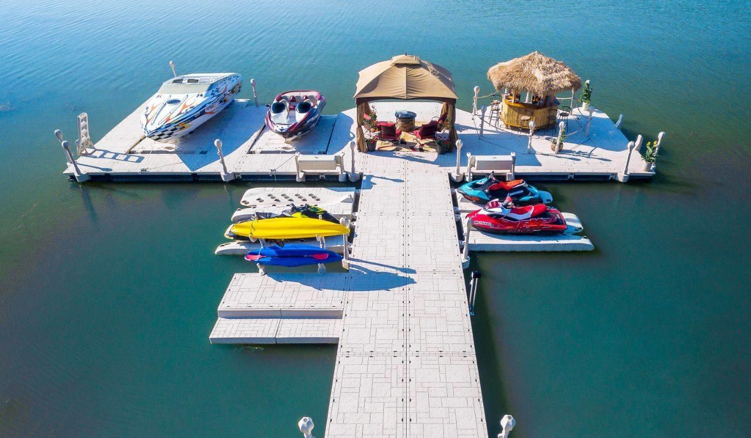

## Advertising for The Evolution

Thank you for being part of the Wave Armor Team! We want to introduce you to the 2021 Co-op program benefits that are available to you. Your marketing and advertising are a direct reflection of who you are as our business partners. We are committed to providing uncompromising service and delivering the tools needed to grow your business and expand your customer base. Wave Armor is committed to becoming the most respected brand in the marketplace.

## Wave Armor Co-op Marketing Program

Our Co-op program is designed to benefit our dealers and is intended to drive your marketing efforts to new heights. With our vision of offering the highest levels of quality and customer service, Wave Armor is here to support you in bringing this message to the customer.

We look forward to working with you and providing all the tools and resources to elevate your marketing success at all levels.

## The Competitive Wave

* + **Best in class innovation** – Continuous development of new truly unique products and accessories
  + **Unmatched quality** – Made in the USA. Roto-molded & Foam Filled. Wave Armor docks and ports are the most durable and unsinkable floating docking systems in the industry
  + **Most aesthetically pleasing dock** - Molded flagstone texture, multi-colored Pebble Beach finish, and patented hidden H-Beam connectivity make it the most beautiful dock on the market
  + **Ultimate customization** – Wave Armor Docking systems are modular accommodating any dock design and provide the widest variety of accessories to turn docks into true outdoor living spaces
  + **Best in class warranty**:
    - 10-year residential warranty on docks, 8-year residential warranty on ports
    - 3-year commercial warranty on docks and ports
  + Preparing you for success -
    - Best in Class Sales, Marketing and Customer Service team for you and your customers
    - The Wave Armor team is always available and can provide you the tools, training, and resources necessary to be successful
  + **Telling our story** – We are continuously building Wave Armor brand awareness and providing our dealers with tools to connect with new customers. Dealers have access to:
    - Content – New articles consistently produced on Wave Armor products, info, tips, features, and benefits.

Dealers to use socially, email newsletters, website, and in-store

* + - New lifestyle & product images added annually to showcase Wave Armor products, and to keep your marketing assets fresh and up-to-date
    - Library of videos to use as needed, with new videos added annually
    - Sales support materials – catalogs, sell sheets
    - Dealer kits – full of logo wear and promo items

Along with these items, we are introducing Dealer Promotions to give you even more support to run your business.

TABLE OF CONTENTS

# ADVERTISING GUIDELINES

 **Qualifying for Co-op**

 **Accrual, Reimbursement**

* + - **Period – Annual Program Period**
    - **For Purposes of Co-op Accrual**
    - **Co-op Claim Submittal**
    - **Co-op Reimbursement**
    - **Co-op Claim Status and Balances**

 **Program Dates, Submission Deadlines**

 **Important Information**

 **Advertising and Marketing Resources (FTP Site)**

 **Minimum Advertised Price (MAP) Policy**

**QUALIFIED ADVERTISING**

 **Print Media**

 **Digital Advertising (SEO Programs, Social Media)**

 **Radio and Television**

 **Shows, Expo’s and Events**

 **Apparel, Banners and Misc. Items (Wave Armor Branded)**

 **Classified Advertising**

 **Promotional Programs and Products (Giveaways)**

**DISCLAIMER**

 **Right to Deny Any Claim**

 **Right to Change this Co-op Program**

 **Interpretation of Any Claim**

 **Submission of Falsified or Fraudulent Claims**

**ADVERTISING GUIDELINES**

**QUALIFYING FOR CO-OP:**

* The qualifying dealer must be in good standing with Wave Armor LLC and the Territory Sales Manager that is responsible for the territory.
* Advertise, market, and have the ability to sell multiple lines of Wave Armor products. Any single line dealer will need to have written consent from Wave Armor LLC to receive co-op upon any single product.
* Represent and promote Wave Armor products on a dedicated area of your website, for which we will provide you with the product images and specifications to achieve this.
* Advertise Wave Armor products following our Minimum Advertised Price (MAP) structure.
* Display POP Material and brochures prominently in the Dealer’s showroom or office. (Dependent upon space)
* Display Wave Armor product in the showroom or lot as applicable. (Dependent upon space)
* Follow Wave Armor branding guidelines and FTP site images for all logo and brand use, including all marketing materials (Any digital or printed materials that are not created by Wave Armor must have approval from a Wave Armor’s representative prior to distribution).

**CO-OP ACCRUAL AND REIMBURSEMENT:**

**PERIOD: October 1, 2020 through September 30, 2021 (Annual Program Period)**

**FOR PURPOSES OF CO-OP ACCRUAL**

* Co-op funds will be accrued on all Wave Armor Products purchased directly from Wave Armor LLC during the previous Product Year.
* Co-op funds will be calculated as a percentage of the total annual dollar value of purchases minus any outstanding or unpaid funds as determined by the accounting department.
* Special Promotions, seasonal promotions, blowouts, demo products and any closeout/discontinued products may or may not qualify for Co-op funds. It will be at the discretion of Wave Armor LLC on these products.

**CO-OP CLAIM SUBMITTAL:**

* All Co-op claims will be emailed directly to [customerservice@wavearmor.com](mailto:customerservice@wavearmor.com)
* All claims should be submitted for pre-approval before the event and/or advertising start date (ASD).
* Claims that are not submitted for pre-approval can be submitted within 60 days after the ASD and must include documentation (Co-op Advertising Claim Form) and proof (pictures or receipts).
* All claims submitted (including after 60 days of ASD) are subject to review for acceptance or denial (with explanation) on a case by case basis.

**CO-OP REIMBURSEMENT:**

* Dealers and Distributors will receive Co-op reimbursement as account credit (credit memo) that can be used towards the purchase of Wave Armor products. No checks will be sent directly to Dealers, Distributors or vendors.
* Approved claims will be reimbursed at 50% of the qualifying advertising cost and will be subject to the advertising requirements and available Co-op accrual balance.
* All approved reimbursement funds will be applied to the account balance within 60 days of approval.

**CO-OP CLAIMS STATUS AND BALANCES:**

* Initial Co-op balances will be emailed to the primary contact on file at the beginning of the Annual Program Period.
* All claims status and balance inquiries can be made through the Territory Sales Manager or by sending a “Co-op Status Inquiry” with the Dealer or Distributor information to [customerservice@wavearmor.com](mailto:customerservice@wavearmor.com).

### PROGRAM DATES AND SUBMISSION DEADLINES:

**PERIOD: October 1, 2020 through September 30, 2021 (Annual Program Period) SUBMISSION DEADLINES:**

* All Co-op claims will be submitted directly to [customerservice@wavearmor.com](mailto:customerservice@wavearmor.com) no later than September 30th of the prior Annual Program Period.
* No claims submitted after the end of the Annual Program Period will be reviewed for Co-op utilizing existing funds.

### IMPORTANT INFORMATION:

* Co-op Claims submitted to an account that has insufficient funds will be placed on hold for further status review and/or to determine if partial payment will be accepted for reimbursement.
* A Co-op Claim Form will be submitted with each advertising opportunity for review. Please do not apply more than one request per form.
* Any unused or un-submitted (not pending approval) Co-op funds will be forfeited at the end of the Annual Program Period. There will be no funds rolled over to another Annual Program Period.
* Any claims that do not meet the requirements for approval will be denied with explanation. Any claims missing documentation can be resubmitted for status review.
* LOGO Requirements: A Wave Armor Logo must be present on all forms of advertising or at all events that are submitted for Co-op status review.
  + Shows, Expo’s and Events will require Wave Armor banners/signs and products be present for co-op.
  + All advertising media such as TV, print, billboard and digital will require that the Wave Armor logo and name be a prominent portion of the ad and non-competing.



* + All advertising media such as TV, print, billboard and digital that represents multiple products other than Wave Armor will not be considered for co-op.
* Website setup fees and maintenance costs are not eligible for co-op reimbursement.
* Competitive products are not acceptable. Ads mentioning a competitive product in the text of the ad or displaying competitive products will be denied regardless of whether or not the business carries a corresponding product line. This includes, but not limited to Docks, Ports, Rafts, Universal Products, Dock wheels and Coolers.
* Creative development, art, talent, photography, travel, lodging, web site development, live or remote radio or television broadcasts, agency fees, production costs, labor charges, taxes, rentals, operating costs, shipping, handling, photo charges and commissions do not qualify for co-op.

### ADVERTISING AND MARKETING RESOURCES:

* Please refer to your Dealer or Distributor Handbook to review all “Advertising and Marketing Assets”.
* Wave Armor Dealers and Distributors have access to the FTP Site containing many available advertising resources.
* FTP Site Access:
  + Online access to Wave Armor Product Images, Lifestyle Photos, Videos, Sell Sheets, Installation Instructions, Logos, Warranty Info and more.
    - Go to [www.wavearmor.com](http://www.wavearmor.com/)
    - Click on FTP Login in the top navigation bar
    - Username: **wavearmorftp**
    - Password: **Genesis2021**
    - Click on the Wave Armor Folder
    - Navigate from here as needed

### MINIMUM ADVERTISED PRICE (MAP) PROGRAM:

All advertising will follow the Wave Armor MAP Program as offered in the Wave Armor Dealer Handbook for PY2020. Any co-op claim submitted with an advertised price or described value shall be reviewed for MAP Program participation and compliance.

MAP Program Example: 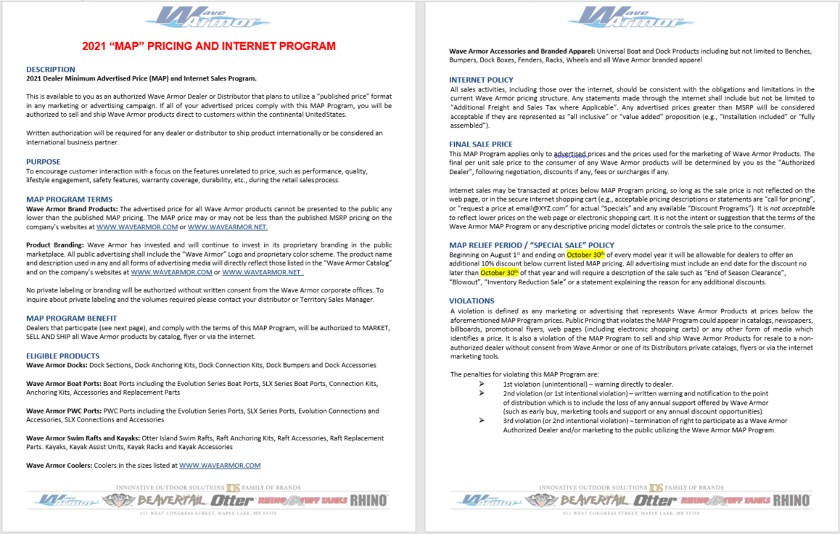

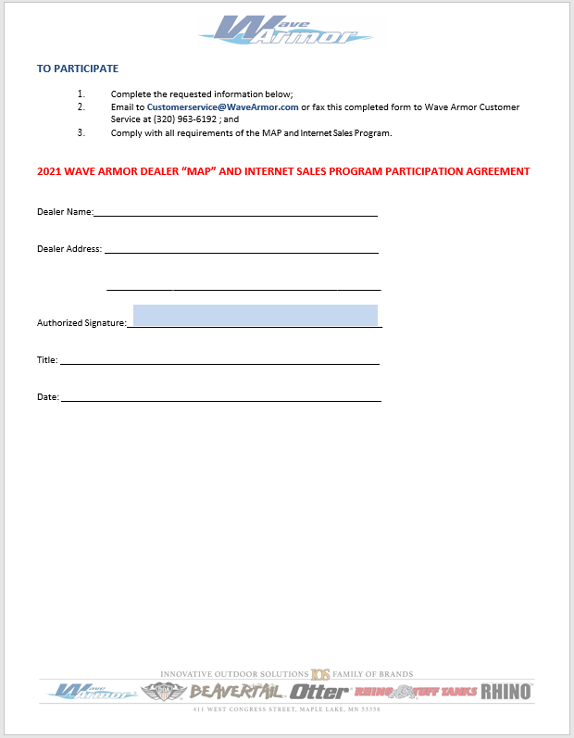

# QUALIFIED ADVERTISING

### PRINT MEDIA:

* Newspaper, Magazines, Direct Mail
* Wave Armor product and Wave Armor logo must be a prominent part of the message with the Wave Armor logo size comparable to the dealer name.
* There must be at least one clear picture of a Wave Armor product.
* Text must include appropriate description of features, benefits and/or the lifestyle that Wave Armor products represent if text is used.

Submit:

* Completed Co-op Advertising Claim Form
* Original full-page tear sheet from each publication date (showing name and date of publication), or affidavit of performance notarized with one copy of an original full-page tear sheet.
* Invoice for each ad or receipts for direct mail printing and postage. (Invoices listing many different advertisements should have the Wave Armor ads clearly marked.)
* Full invoice showing net cost, less any discounts (statements are not acceptable). Agency fees, commission, and photography fees are not eligible.

### DIGITAL ADVERTISING (SEO PROGRAMS, SOCIAL MEDIA):

* + **\***The following media types are eligible for co-op reimbursement ONLY IF THE CAMPAIGNS ARE PRE-APPROVED by the Wave Armor social media department.

**SEARCH ENGINE OPTIMIZATION (SEO PROGRAMS):**

It is generally a best practice when setting the parameters of your campaign to limit your geographic area. This will help you get the best cost and the best return on your campaign. The display URL (the web address that shows in your ad) cannot feature a competitor name. If your website URL has a competitor name within it, you should consider purchasing a co-op approved URL that you can use in advertising that redirects to your main site. Landing pages for ads should be specific and relevant to each ad. The example of “Wave Armor is the most innovative floating dock brand in the world” is specific to the product and the message that we use to engage with customers.

* + **Best** – no competitor information at all, only Wave Armor.
  + **Acceptable** – competitor logo in website header as part of dealer name and/or lines carried by dealer, but no mention of competitive product or logos elsewhere on the page.
  + **Not approved** – competitor logo anywhere on the Wave Armor landing page of your website that links to another page or any page featuring a competitor’s brands or product.
  + When you have planned out all of the above, submit to Wave Armor social media department for co-op pre- approval and include the following:
    - Copy of each ad
    - Screen shot of landing page for each ad
  + After receiving co-op approval or making changes necessary to meet co-op approval, take your campaign live.
  + **Example campaign report for Google AdWords that serves as the third party/vendor invoice or receipt required for filing your co-op claim**
    - A report showing destination/landing page URL.
    - Traffic via click per word or link
    - Tools and Analysis tab within Google AdWords.
    - Separate keywords report if they are not included on the invoice/receipt.
    - Destination/landing page URL report.
    - Copy of pre-approval from the Wave Armor.

Submit:

* Completed Co-op Advertising Claim Form
* Invoice for each ad or receipts for direct Social Media company (i.e., Facebook, Twitter, Instagram)
* Invoice/receipt/report must show the campaign dates, amount spent, and campaign reach (impressions and/or clicks).

**SOCIAL MEDIA ADVERTISING (FACEBOOK, INSTAGRAM, TWITTER, ETC.)**

* + With Facebook ads, your advertising is best suited when it is targeted towards Facebook users that are commonly interactive with products descriptive of a lifestyle activity. The most common and relevant ads for Wave Armor dealers are:
    - **Page Likes** – Builds likes for your dealership Facebook page
    - **Clicks to Website** – Drives traffic to your dealership website
    - **Event Responses** – Promotes and encourages attendance at upcoming events (open houses, demos, etc.)
    - **Offer Claims** – Drives traffic into your store with incentive offers to customers
  + You can create custom ads for any ad type, but MUST submit them to Wave Armor for pre-approval before beginning your campaign. Facebook ad image sizes and text length will vary somewhat depending on the type of ad you run, but the most common is 1200x450 pixels with 90 characters of text.
  + Twitter ads are limited to 140 characters including any links within your post. Custom ads must follow current Wave Armor Co-op guidelines.
  + For pre-approval, you will need to submit the Ad Image (for Facebook and Instagram) and Ad Text (Facebook or Twitter) you wish to run. When setting up your ads, make sure that they link directly to the most relevant landing page for your ad type. Page Like ads will go to your Facebook page; event ads should link to an event you have created and Clicks to Website ads should go to a relevant page on your website.

Submit:

* Completed Co-op Advertising Claim Form.
* Third party/vendor invoice or receipt for the media buy.
* Invoice/receipt/report must show the campaign dates, amount spent and campaign reach (impressions)

### RADIO AND TELEVISION:

* + Radio: Wave Armor must be the prominent part of the message with Wave Armor mentioned at least twice in a 30 second spot or three times in a 60 second spot.
  + Television: Wave Armor must be mentioned at least once in a 30 second or twice in a 60 second spot. The Wave Armor Logo with must be superimposed on the screen or shown in the visuals. Ads must include the appropriate explanation of the features and benefits for the product being advertised.
  + Co-op reimbursement can be used for TV or radio space only. Production costs will not be reimbursed.

Submit:

* + - Completed Co-op Advertising Claim Form.
    - Digital copy of ad. Original notarized script for each advertisement, including the audio and visual portions of the script including any superimposed items such as the Wave Armor logo.
    - Video tapes, CD’s and DVD’s will not be accepted.
    - List of intended market reach (gender, age, geographical area, etc.)
    - Invoices for each ad. (Invoices listing many different advertisements should have the Wave Armor ads clearly marked.) Invoice needs to show net cost of time, including any discounts and agency fees.

### SHOWS, EXPO’S AND EVENTS:

* + Wave Armor will pay up to 50% of the exhibit space dedicated to Wave Armor, plus rented flooring/carpeting, up to the maximum reimbursement of $4000 per occasion as shown below.
  + Display area must be for Wave Armor products. Accessories can be displayed but cannot make up the entire booth space.
  + Set-up, dismantling and operating costs **do not** qualify for co-op. (Ex.: electrical, freight, labor, rentals, etc.)
  + Consumer show reimbursement will be determined based on the “Display Reimbursement Schedule” below.
    - *NEW for 2021 - Carpet can be included in the booth co-op reimbursement

Submit:

* + - Completed co-op advertising claim form.
    - Copy of contract, invoice, bill, receipt or copy of cancelled check showing proof of payment and/or amount owed. Contract is not proof of payment.
    - Photographs of your entire booth, including all competitive products displayed in it.
    - Detailed diagram of your booth space with all display items clearly labeled
    - “Dock Builder” is available at [www.wavearmor.com](http://www.wavearmor.com/) and can be used to setup a booth display diagram. See example below.

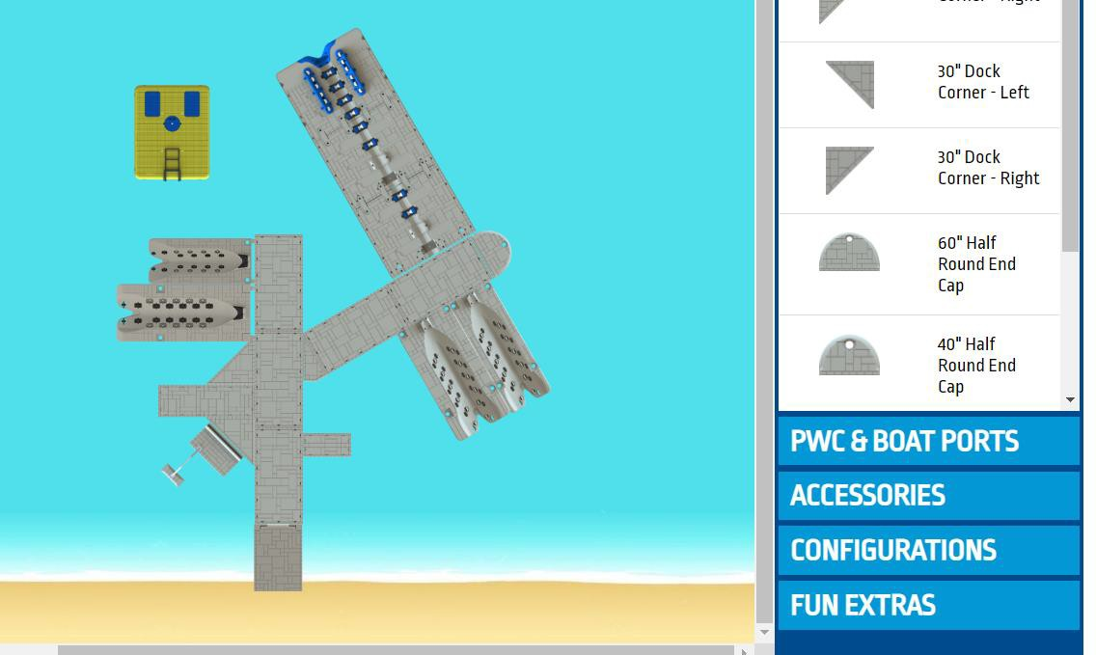

* + Partial credit can be given if the accrued or remaining funds are insufficient to cover the full amount requested. Dealers cannot roll expenses or funds from one program year to another.
  + If pictures are lost or not clear, claims must be submitted for review by a Territory Sales Manager, verifying that the display is correct.
  + DISPLAY REIMBURSEMENT SCHEDULE:
    - Booths with 100% Wave Armor product will qualify for 50% reimbursement with a maximum of $4000 per occasion.
      * Ex., 400 Sq. Ft. Booth space costs $4500, Wave Armor occupies ***400*** Sq. Ft, and Carpet cost is $1000. Reimbursement = $2750
      * Ex., 400 Sq. Ft. Booth space costs $4500, Wave Armor occupies ***200*** Sq. Ft, and Carpet cost is $1000. Reimbursement = $1375
    - Additional bonus Co-op fund reimbursement can be pre-approved for common area, main isle or special opportunity presentations of Wave Armor product with a Maximum of $750. *PRE-APPROVAL REQUIRED
      * Ex., Genesis G20 highlighted in the “Main Lobby” with signage and flags surrounding product. “Special Opportunity” Booth space costs $1250, Reimbursement = $625

### APPAREL, BANNERS AND MISC. ITEMS (WAVE ARMOR BRANDED):

* + Please refer to your Dealer Handbook and view the “Marketing Resources Order Form”
  + Apparel items (incl. keychains, trade show banners) will qualify for 50% reimbursement of the total purchase price.
  + Apparel, banners and misc. items are not to be resold in any capacity when purchased under this co-op program.
  + **Maximum Reimbursements**
    - Dealer maximum reimbursement:
      * Apparel - $350 per year.
      * Banners and Signage - $1000
    - Distributor maximum reimbursement:
      * Apparel - $700 per year.
      * Banners and Signage - $2000
  + **TRADE SHOW BANNERS**
    - Here's a great resource for affordable tradeshow banners that come in 10 or 20 ft widths, flat or serpentine shapes.
  + **Product Pricing Artwork Ends In**
  + 20'X8' FLAT TRU-FIT 3.0 $1200-$2000 FTF3-20x8F
  + **LINK:** https://[www.aceexhibits.com/tru-fit-3-0-20ft-flat-tension-fabric-display.html](http://www.aceexhibits.com/tru-fit-3-0-20ft-flat-tension-fabric-display.html)
  + 10'X8' SERPENTINE TRU-FIT 3.0 $600-$1200 FTF3-10x8S
  + **LINK:** https://[www.aceexhibits.com/tru-fit-3-0-10ft-serpentine-tension-fabric-display.html](http://www.aceexhibits.com/tru-fit-3-0-10ft-serpentine-tension-fabric-display.html)
  + 10'X8' FLAT TRU-FIT 3.0 $600-$1200 FTF3-10x8F
  + **LINK:** https://[www.aceexhibits.com/tru-fit-3-0-10ft-flat-tension-fabric-display.html](http://www.aceexhibits.com/tru-fit-3-0-10ft-flat-tension-fabric-display.html)

### CLASSIFIED ADVERTISING

* + Wave Armor product must be the only item mentioned.
  + The Wave Armor logo must appear in the ad or alternatively, the word “Wave Armor” must be shown in bold letters.
  + Any pictures used must represent Wave Armor products with the highest level of quality and detail possible.

Submit:

* Completed co-op advertising claim form.
* Original full-page tear sheet from each publication date (showing name and date of publication), or affidavit of performance notarized with one copy of an original full-page tear sheet.
* Invoice for each ad with the ad clearly marked, or notarized proof of publication. (Invoices listing multiple different ads should have the Wave Armor ads clearly outlined.)

### PROMOTIONAL PROGRAMS AND PRODUCTS (GIVEAWAYS):

* + **MUST BE PRE-APPROVED BY A TERRITORY SALES MANAGER OR WAVE ARMOR CORPORATE OFFICE. **
  + Giveaway unit must be part of an advertising promotion.
  + Giveaway cannot be tied to the purchase of any product other than Wave Armor without approval from a Territory Sales Manager.
  + Coolers, cups, hats, limited edition, non-standard or custom ordered items etc. are eligible for co-op. Promotional giveaway must be imprinted with the Wave Armor Logo. These items are for advertising and give-away purposes only and ***cannot*** be sold or used as retail items. Items must be purchased directly from Wave Armor.

# DISCLAIMER

**Right to Deny Any Claim**

* + Wave Armor reserves the right to deny any claim for reimbursement that could be considered offensive, unpleasant, or inappropriate in any way and for any reason.
  + *Any items purchased from* ***third party vendors*** *must contain an approved Wave Armor logo and must be pre- approved.*

**Right to Change this Co-op Program**

* + Wave Armor reserves the right to change this program at any time with or without notice to the dealer or distributor.

**Interpretation of Any Claim**

* + Wave Armor reserves the right to interpret any advertising and/or claim for co-op reimbursement at its sole discretion. Any interpretation will be considered final.

**Submission of Falsified or Fraudulent Claims**

* + Wave Armor reserves the right to retract co-op funds if the marketing opportunity is found to be fraudulent or falsified in any way. The Dealer/Distributor account will then be audited and any existing funds will be suspended until further review.